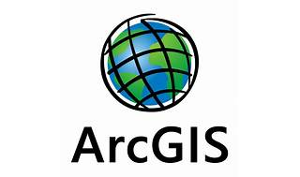

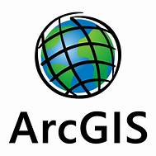

Explore

[**ArcGIS Server** is a back-end server software component of **ArcGIS Enterprise** that makes your geographic information available to others in your organization and, optionally, anyone with an internet connection1](https://enterprise.arcgis.com/en/server/latest/get-started/windows/what-is-arcgis-for-server-.htm). Here are **five free reference links** where you can learn more about ArcGIS Server:

1. [**Esri Training**](https://www.esri.com/training/): Explore a wide range of resources, including live training seminars, self-paced courses, and classes taught by Esri experts[2](https://www.esri.com/training/).
2. [**Esri Academy Learning Plans**](https://community.esri.com/t5/esri-training-blog/top-5-esri-academy-learning-plans/ba-p/1189962): Self-paced learning plans that include web courses, tutorials, videos, and instructor-led courses[3](https://community.esri.com/t5/esri-training-blog/top-5-esri-academy-learning-plans/ba-p/1189962).
3. [**ArcGIS Hub**](https://www.learn-arcgis-learngis.hub.arcgis.com/): Discover, analyze, and download data, create storymaps, and explore webmaps[4](https://www.learn-arcgis-learngis.hub.arcgis.com/).
4. [**What is ArcGIS Server? (Esri Documentation)**](https://enterprise.arcgis.com/en/server/latest/get-started/windows/what-is-arcgis-for-server-.htm): Detailed information about ArcGIS Server and its capabilities[1](https://enterprise.arcgis.com/en/server/latest/get-started/windows/what-is-arcgis-for-server-.htm).
5. [**ArcGIS Server - Wikipedia**](https://en.wikipedia.org/wiki/ArcGIS_Server): An overview of ArcGIS Server as the core server GIS software made by Esri[5](https://en.wikipedia.org/wiki/ArcGIS_Server).

Feel free to explore these resources to enhance your understanding of ArcGIS Server! 🌐🗺️